**Q1. Create A Permissioned Network using GETH of 2 Nodes.**

**Steps:**

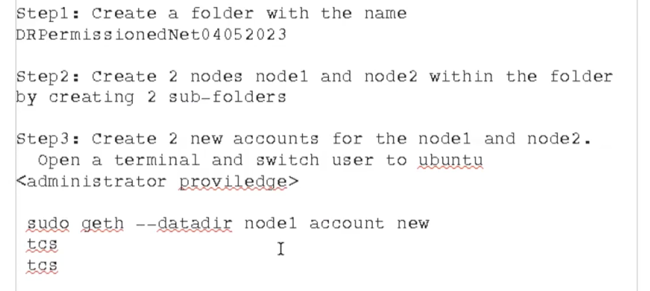

-> Enter su ubuntu and admin password for admin access

Account of Node 1:

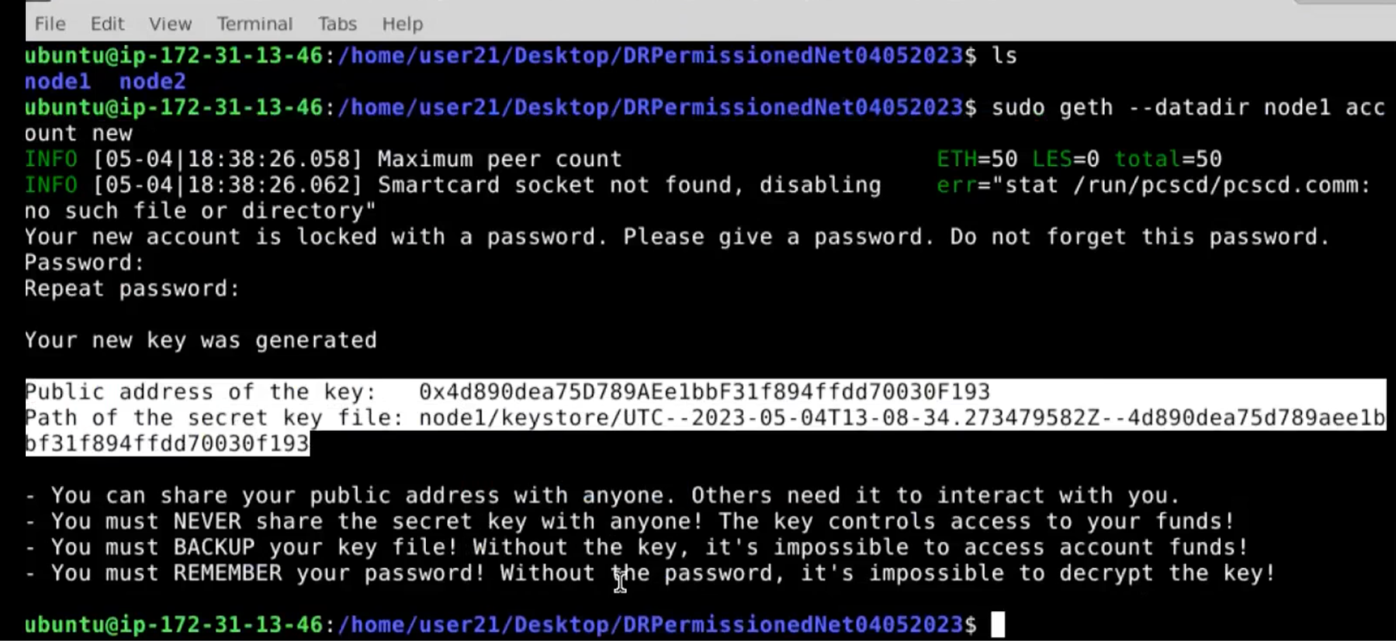

Code:

Sude geth –datadir node2 account new

Tcs

Tcs

Account of Node 2:

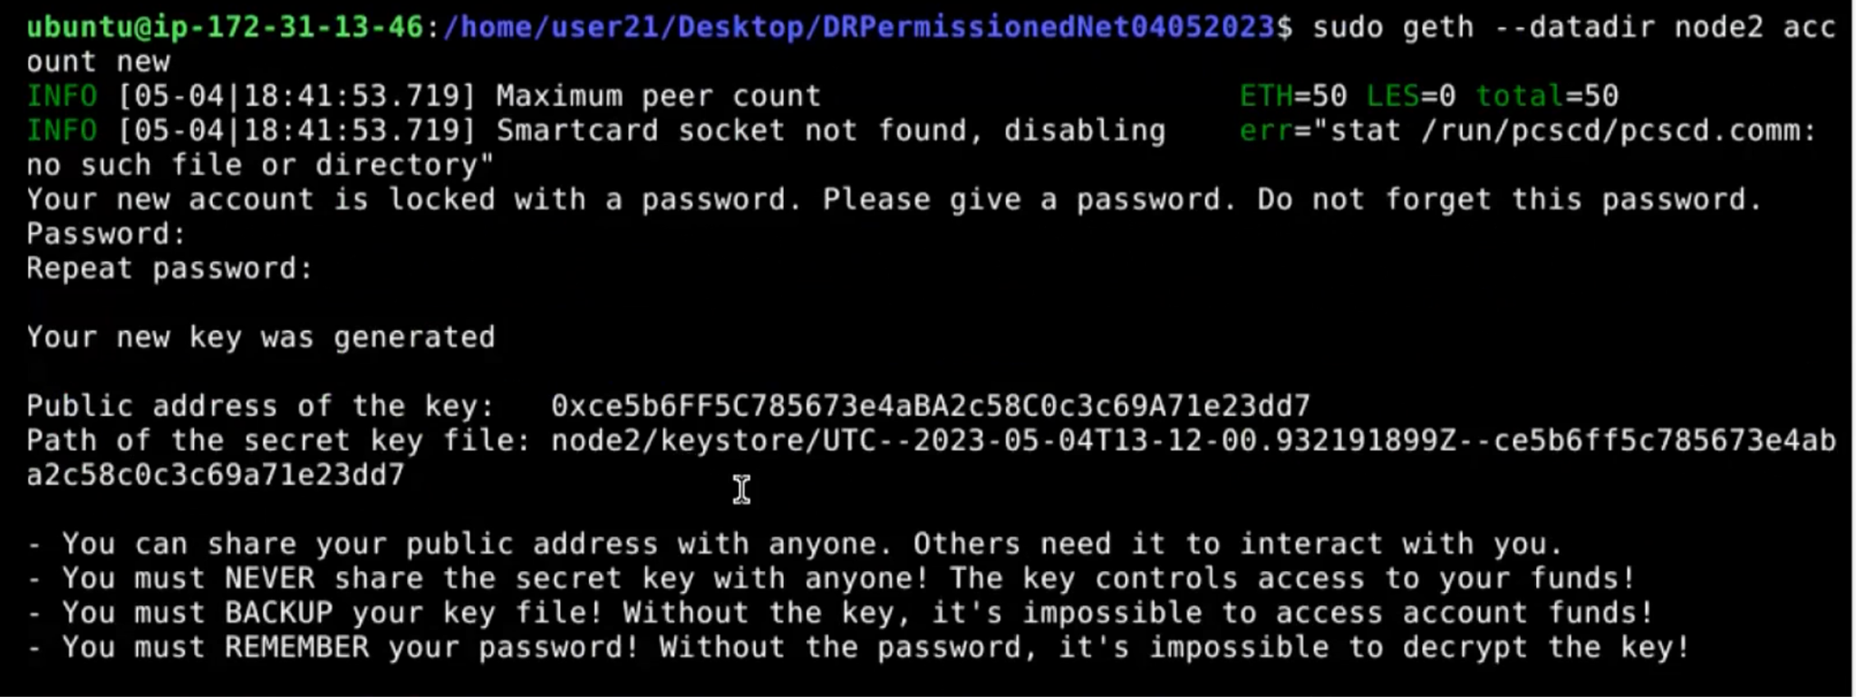

**Document the Public key and Secret key file in the word document**

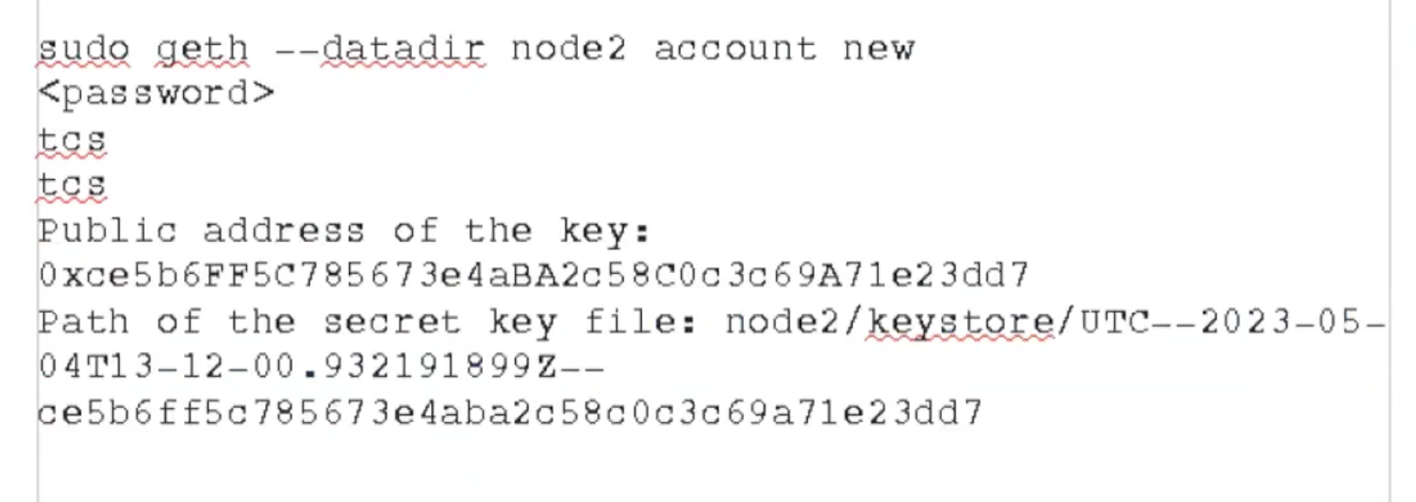

**4. GENESIS BLOCK Configuration: to generate genesis.json file <anyName.json> can be used.**

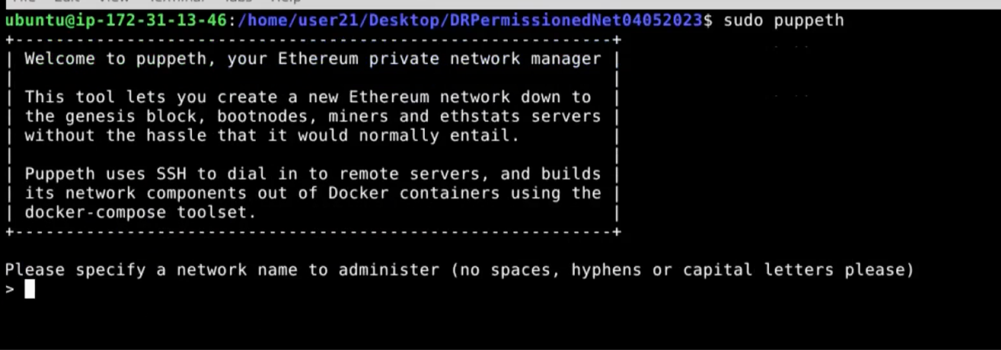

Configure new genesis:

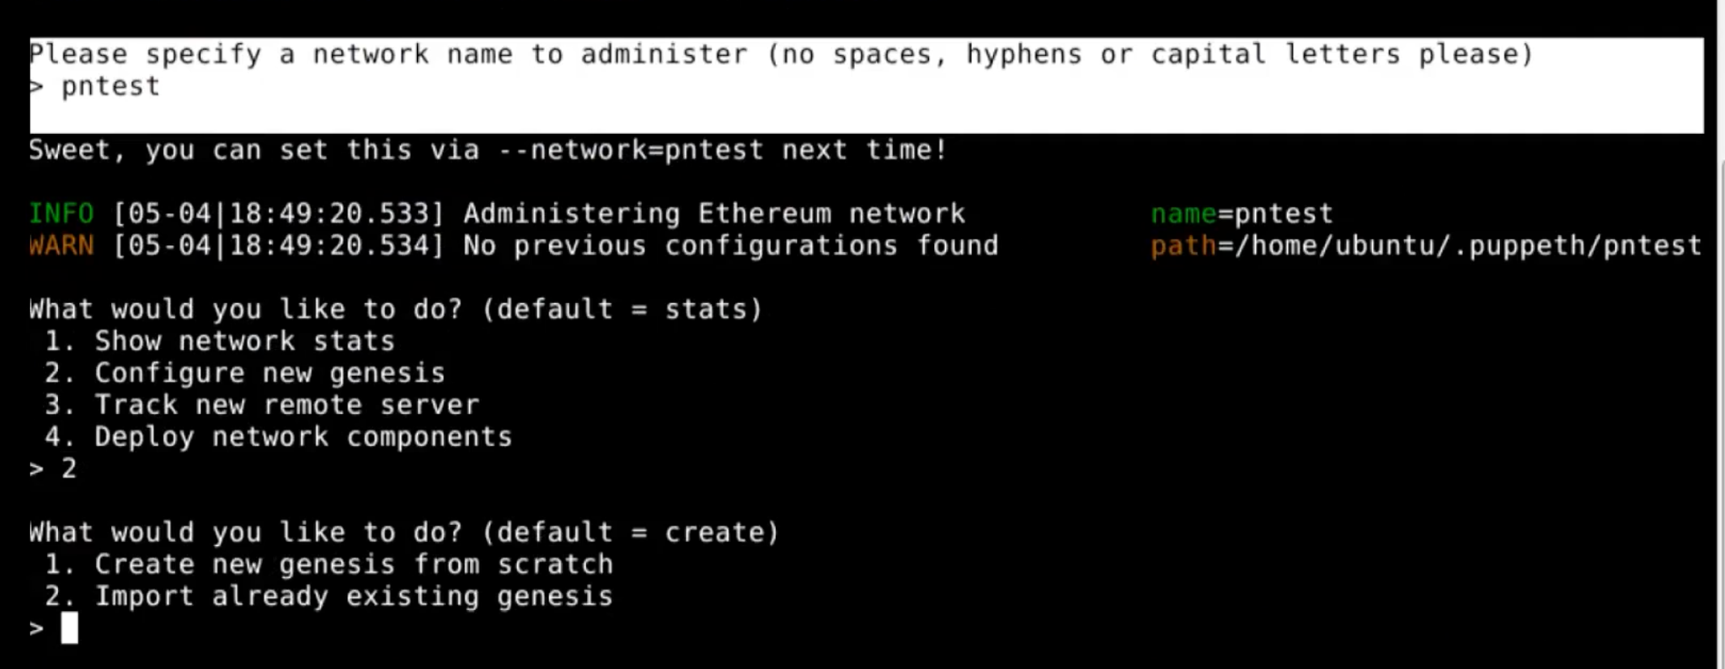

Create genesis from scratch

Use Clique as Consensus Engine

5 seconds

Copy the Address of the first NODE, for seal

Copy the Address of both the Nodes, for pre-funded

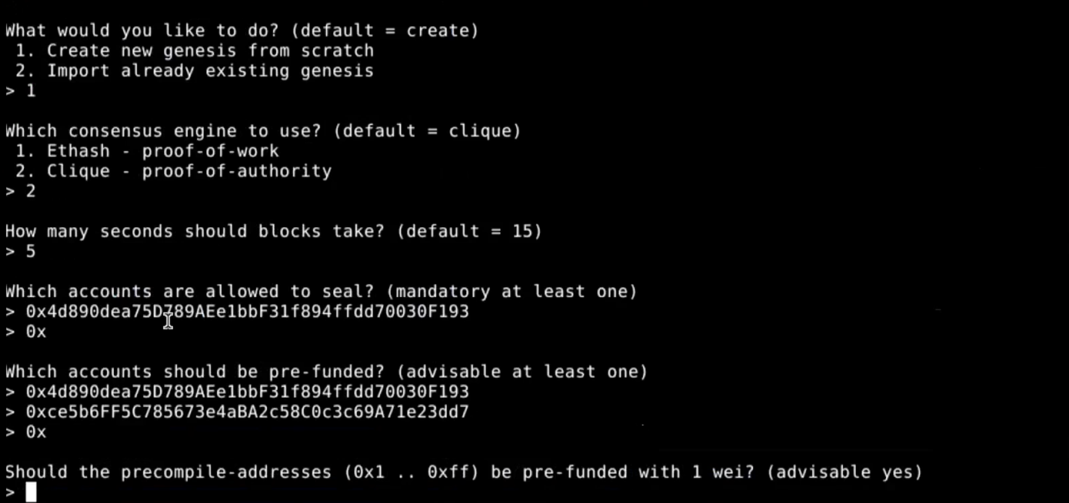

Press enter on procompile-addresses

Specify the chain Id, enter 12345

Manage existing Genesis:

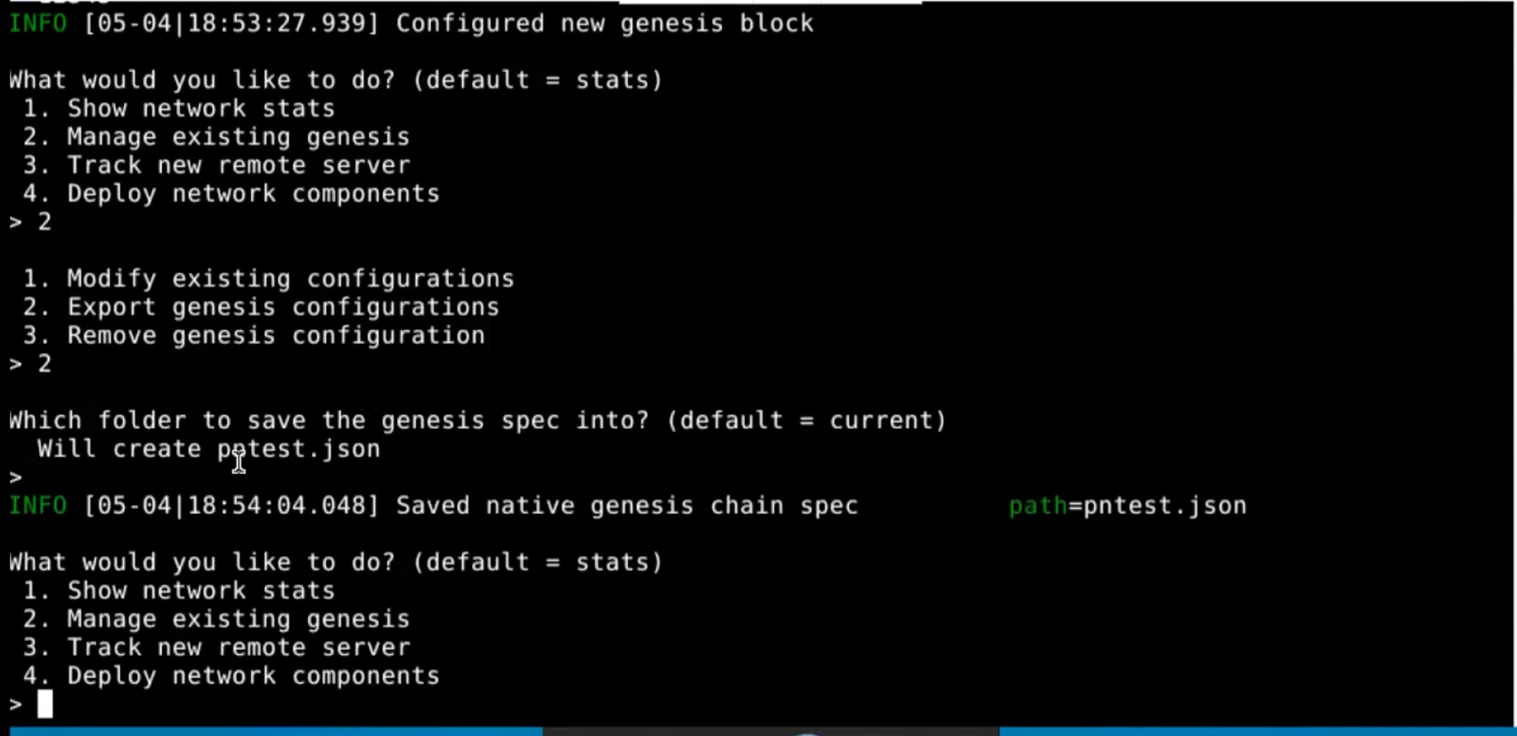

Copy paste all the above cli outputs in the doc file, and press ctrl + D to come out of the process

Edit pntest.json

Sudo vi pntest.json

**Delete under Nonce alloc, until address “4d89…. (100dd)**

:wq save

:q exit without save

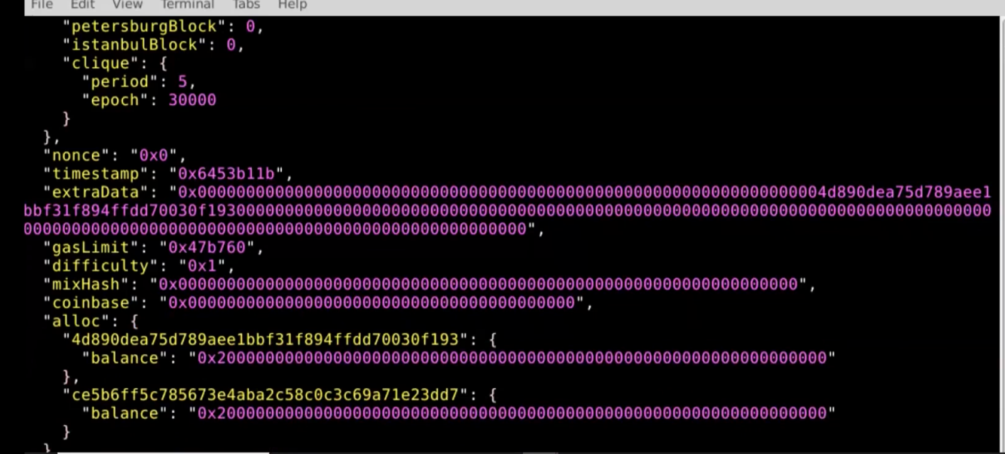

Copy the pntest.json file in node1 and node2 sub dirs

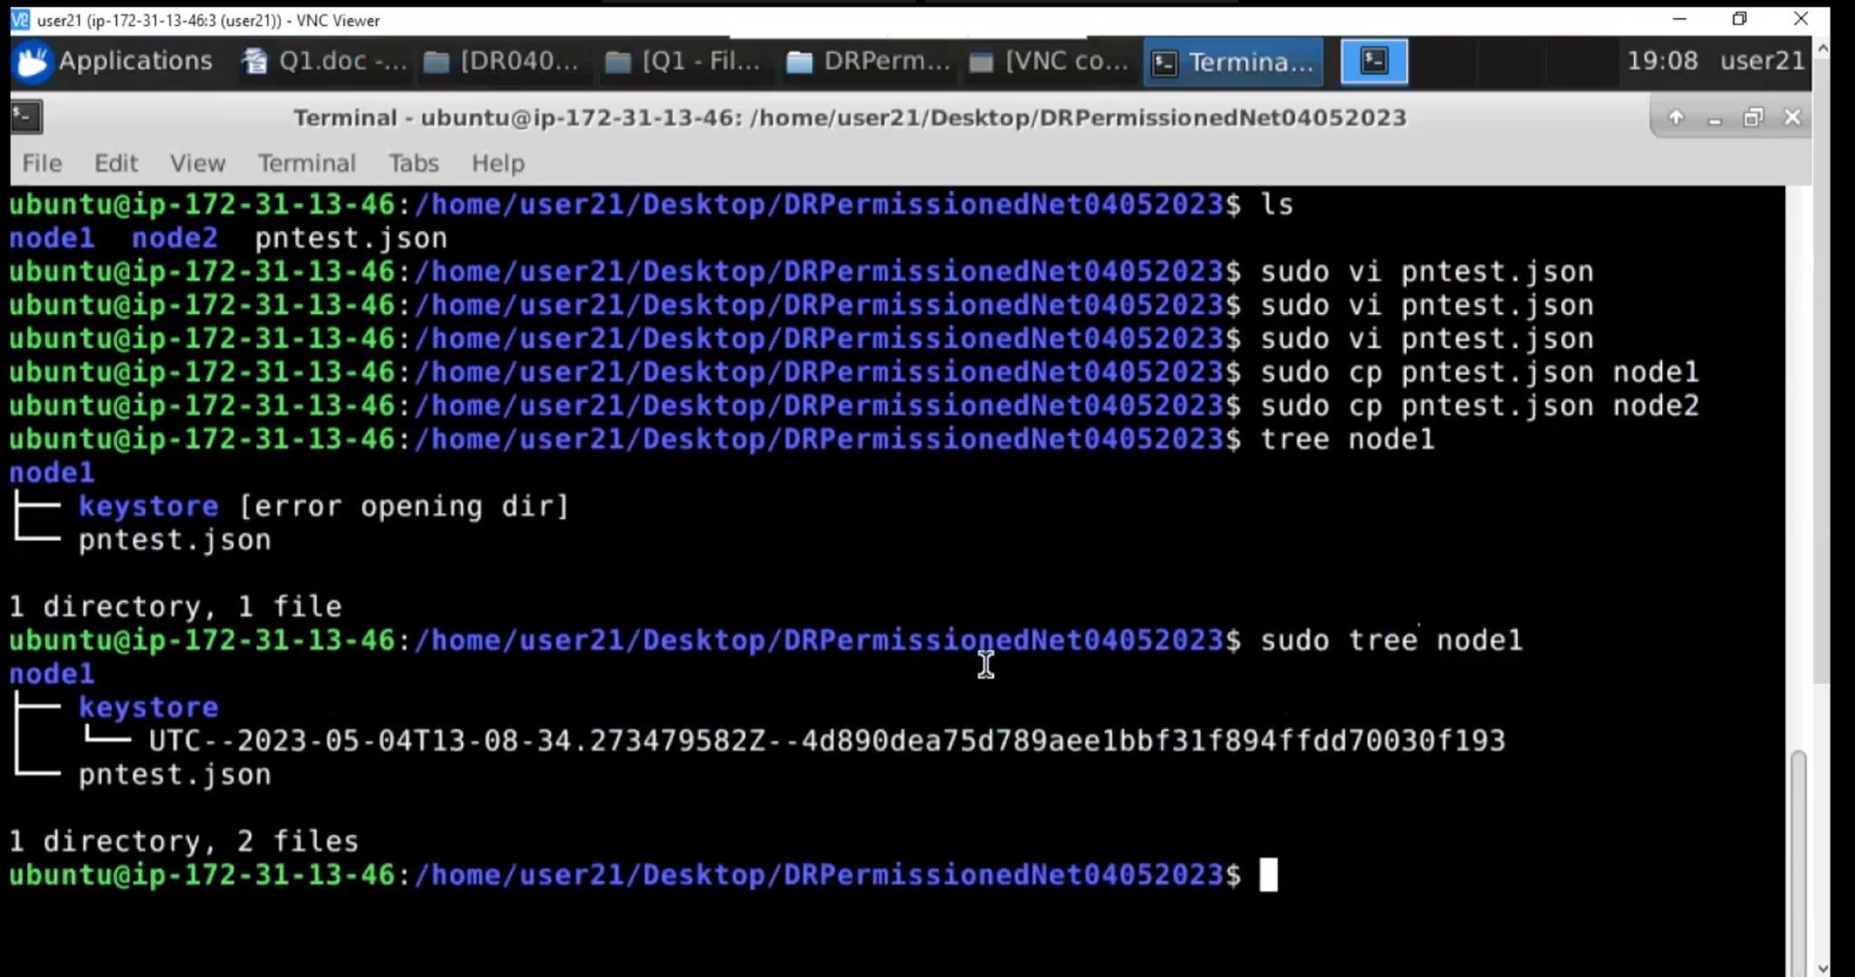

**5. Node Initialization:**

Sudo geth init –datadir node1 pntest.json (initialize both the nodes1 and 2)

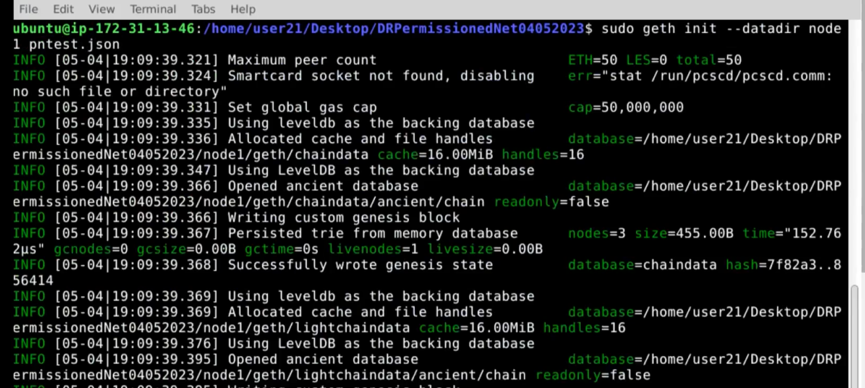

**Initialize the boot node**

Sude bootnode -genkey boot.key

Sudo bootnode -nodekey boot.key -addr: 30310

Copy the enode after the above command

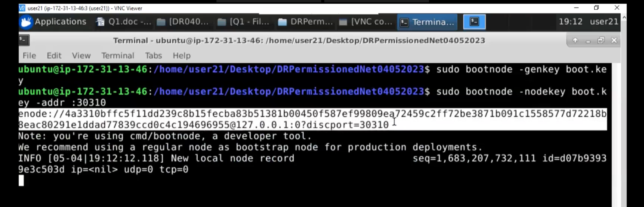

Keep bootnode running and open 2 new terminals, one for each node

Su ubuntu

Password: adminpass

Terminal 1: Run Node 1 (Need bootnodes enode, and node 1 address key)

** The Port should be different than the bootnodes port

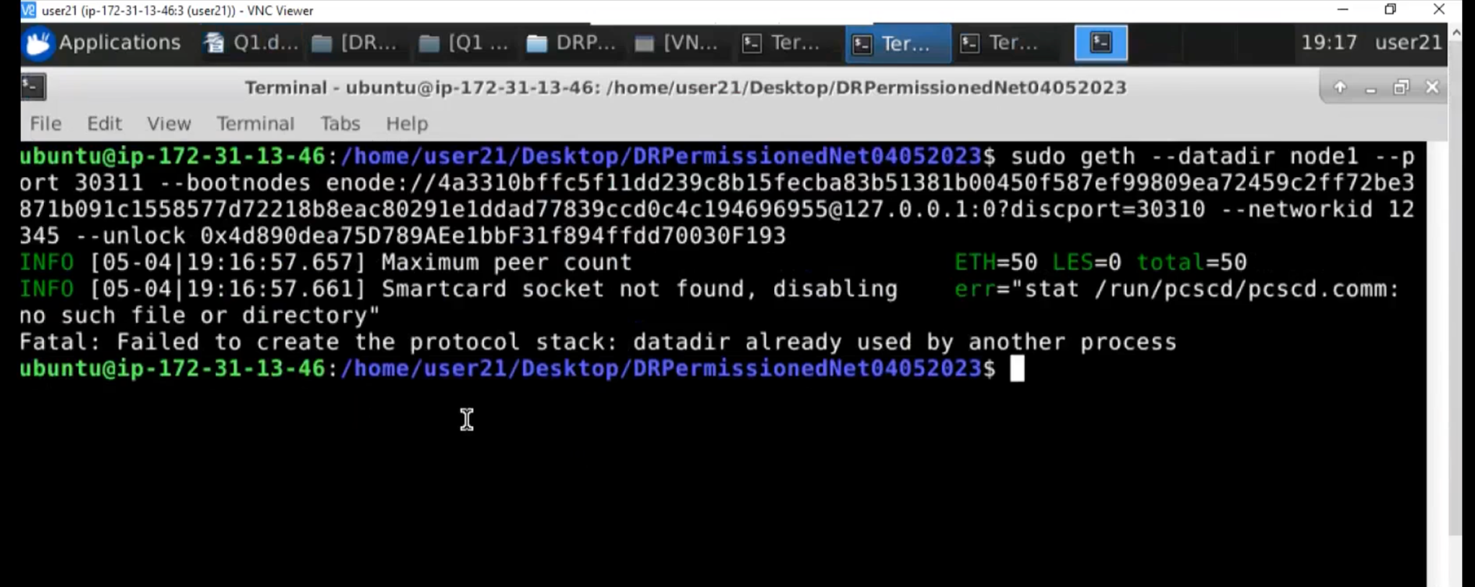

( sudo geth –datadir node1 –port 30311 –bootnodes enode{ Copy Enode Address here } –networkid 12345 –unlock { Copy Node 1 Address Here }) –allow-insecure-unlock –authrpc.port 8554

Terminal 2: Run Node 2(Need bootnodes enode, and node 2 address key)

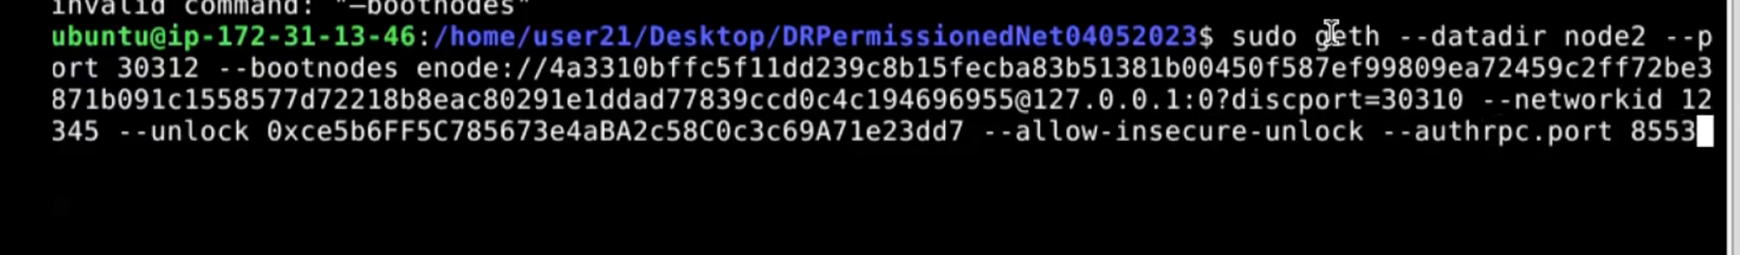

( sudo geth –datadir node2 –port 30312 –bootnodes enode{ Copy Enode Address here } –networkid 12345 –unlock { Copy Node 2 Address Here }) –allow-insecure-unlock –authrpc.port 8555

Peer count is updated when both the nodes are running

